SE 491 WEEKLY REPORT 3 - Requirements Elicitation
sdmay20-25: Consumer Aware Warehouse Management
10/7/19 – 10/14/19
Team Member | Roles
Jimmy Paul  jpaul@craftydelivers.com | Client
Goce Trajcevski  gocet25@iastate.edu | Advisor
Lindsey Sleeth  lssleeth@iastate.edu | Meeting Scribe  Project Manager  Software Developer
Sam Stifter  stifter@iastate.edu | Test Engineer  Software Architect  Software Developer
Omair Ijaz  oijaz@iastate.edu | Quality Assurance Engineer  Meeting Facilitator  Software Developer
Jameel Kelley  jamkelley22@gmail.com | Report Manager  Software Architect  Software Developer
Andrew Smith  arsmith3@iastate.edu | Database Administrator  Quality Assurance Engineer  Software Developer
Elijah Buscho  elijah@iastate.edu | Test Engineer  Software Dev  Proj Manager

Weekly Summary

Objective
The objective of the week was to continue to work with our client and our advisor to understand the requirements for the project by better defining the scope and the context. This includes understanding our Client’s existing solution and needs and gathering that information in a common area and agreeing on outcomes of the project.

Tasks Accomplished
- Define and verify context and scope by creating a context diagram
- Define and verify functional and non-functional requirements
- Create product use case scenarios
- Create product use case diagram showing use cases for our solution
- Create product use case diagram to show use cases of our solution in relation to existing Crafty business operations
- Obtain documentation and walkthrough of current existing frontend solution at Crafty
- Obtain documentation and walkthrough of current formula used to calculate inventory to reorder at Crafty

Summary of Weekly Advisor Meeting
- What are the expectations for us this far in the semester?
- Complete detail and scenario for execution
- Don't wait on the data, figure out the scenarios and project requirements
  - We started with an idea and now we need to do a context diagram, scenarios, and write user requirements because that is the skeleton of our project
  - Identify states the the system will be in and the data that we must extract / how we must respond with every time stamp
  - Stick with 1 - 2 customers and 1 - 2 items and generalize until we continue to build upon and scale the problem
- Until we come up with requirements analysis documentation, then there is going to be a lot of back and forth until it is complete. We must come up with an agreement with our stakeholders.
- Why should anyone be interested in our system? Our client is interested, but why are they seeking our solutions? What existing solutions are there currently to approach the problems highlighted by the scenario, but what needs are not being met through this? Maybe there are reasons that we are using this solution (cost, etc.)
- Look through products in the market, we consulted.. We extended our work with the client, we defined milestones

Past Week Accomplishments (Individual)

Lindsey Sleeth
This week I worked to guide the team in discussions with our client Crafty. The team had a meeting where we made a context diagram in order to better define the scope of our project and to help with creating use cases which will determine our requirements. I worked with Jameel to derive requirements from the product use case scenarios. These requirements were confirmed with our client in a meeting held with the entire team. I guided the group discussion and drew the context diagram on the board while Jameel mocked it up using an online tool during our meeting, as well as, contributed to developing the functional and non-functional requirements. The outcome of the context diagram and functional and non-functional requirements are shown below.

In addition to these, I worked with Jameel and Elijah to come up with product use case diagrams that showed our solution and its use cases, as well as our solution in relation to Crafty’s current business operations.

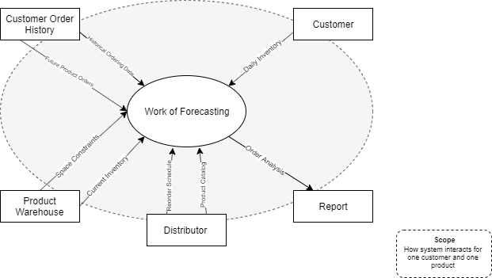
Context Diagram

Functional Requirements
- The system SHALL take data from the Crafty database as input in creating a distributor purchase order
This requirement makes it such that SDMay20-25 software solution will be tied to complying with the format of the current data stored in Crafty’s database.
- For each distributor, the system SHALL make predictions about optimal ordering to maintain product warehouse stock for individual goods provided by that distributor based on previous product orders, current product warehouse stock, current product warehouse space.
The adjacent systems being worked with allow the input of the previous product orders, current product warehouse stock, current product warehouse space. These system inputs will allow the software solution to generate a distributor purchase order output.
- The system SHALL consider future product ordering, which includes new onboarding of Crafty clients and current Crafty clients with needs outside of contract as input when generating orders to be placed to distributors.
Crafty needs a tool that will allow them to account for more than just happy path use cases. Thus the software system needs to have an inbuilt input for special or exception events that would otherwise not be accounted for.
- The system SHALL have a visual component to allow Crafty to interface with the generation of orders to be placed.
The Crafty procurement team needs a way to interface with the system tool to make manual adjustments and view the distributor product ordering report.

Non-Functional Requirements
- The system SHALL be able to handle approximately 1200 SKUs a day
The system in place that Crafty is using is able to handle this number of SKUsin a day. Due to this, the SDMay20-25 software solution must be able to handle this many skus a day at a minimum.
- The system SHALL generate a report on demand that will take less than two minute 90% of the time and will take less than five minutes the remainder of the time in order to satisfy the need for on-demand ordering analysis.
The current Crafty system in place for doing ordering analysis was observed to take less than a minute to generate its results and display it to the view. It is important that the SDMay20-25 solution be no worse than the current system in place in terms of performance.

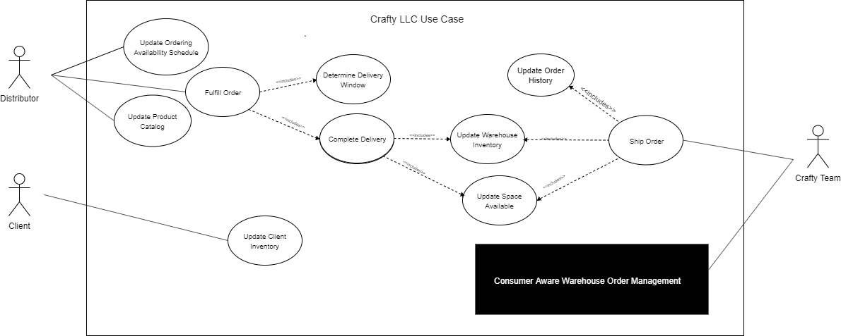
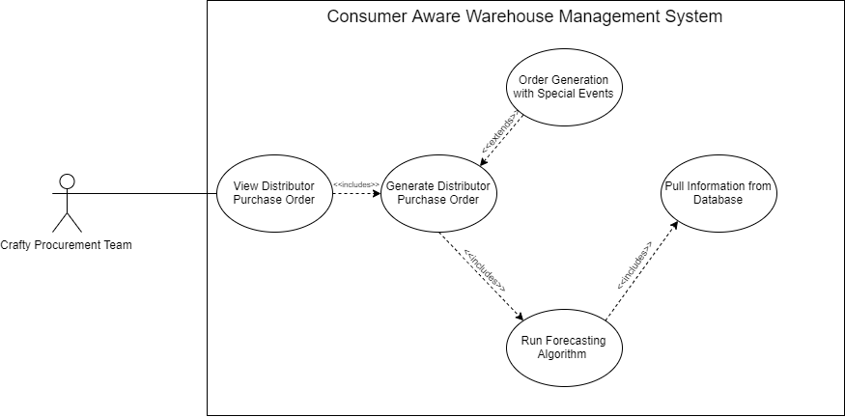
Elijah Buscho
This week I work with the team to develop a context diagram. I also worked with Lindsey and the team to develop a Use Case diagram. We ended up coming up with 2 use case diagrams: one for the whole of Crafty including where our project fits into their company, and another diagram that only included use cases within the scope of our project. Lindsey has included these documents in her section above.
Jameel Kelley
I worked on doing some research into the pipeline for the project. Evaluating many different possibilities landed the most likely choice to be GitLab. This will have to be evaluated at a future date as well when implementing it. Additionally, we had another meeting with our Client to determine requirements on a more fine grained level. I worked on digitizing a product use case (PUC) and architecture diagram for the design document. The PUC can be seen above and the architecture diagram can be seen below.

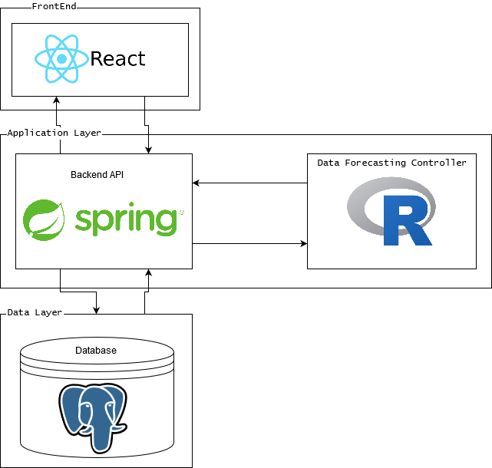
Andrew Smith
I worked on research into the AWS services and PostgreSQL. For AWS server space I researched the EC2 service and for databases I researched RDS.
EC2: is an AWS service that provides a virtual instance of a server for our use. With these servers we can configure most settings such as: security, networking, and managing storage. It will dynamically scale up and down with the use of traffic so we don’t have to worry about traffic size. Each instance of an EC2 server come with an operating system and additional software preinstalled. With the free tier we get 750 hours a month for 12 months. 750 hours comes just above 31 days a month so for our purposes we shouldn’t need to worry about any fees.

Amazon RDS: is a web service that makes it easier to set up, operate, and scale a relational database in the AWS Cloud. It will manage backups, software patching, automatic failure detection, and recovery. It works with both MySQL and PostgreSQL databases so if we need to fall back on just MySQL it can. It allows for all the same features as if we were hosting the database on our own machines. With the free tier we get 750 hours a month for 12 months. The downside is that we only get 20GB free for storage and 20GB for database backup images. We don’t know how much data we are getting so don’t know if there will be any charges for this service. We should be able to host this on our EC2 server.

Omair Ijaz
This week I did research and set up some tools that we will be using for this project. I researched AWS and Time Forecasting. With AWS, I looked into services such as EC2 (a vm that we have OS control over), Amazon Forecast,and AWS Lambda (backend). For forecasting, I looked into sources that defined and expanded on forecasting. I didn’t know about forecasting, so this initial This research was done in pairs. AWS research was done with Andrew, and Time Forecasting research was done with Sam. Researching in pairs consisted of writing our own summaries and gathering our own sources and then meeting together to discuss our findings. The result of our research included writing a summary paragraph about the topic we researched, and then presenting our research outcomes to the group.

The team that will be working on the database and backend includes Sam, Andrew, and myself. Jimmy, our client, gave us his db file which allows us to use the Crafty database locally. We will need to import the db locally and be able to query the db.

Sam Stifter
This week, we were provided with the database import file from the client. I spent some time getting the database imported to a local instance of Postgres Server. With the provided file, we should be able to get an anonymized version of the client’s database. I did some research on Postgres and found out how to make sure the database can get imported correctly. The import file was essentially a list of SQL commands to add all the data from the existing database snapshot.
After figuring out the commands to import the file, it was a matter of running the commands and then figuring out how to make the queries. Luckily, Postgres is very similar to SQL. In fact, my understanding is most any SQL command will run in Postgres. Throughout the process of the import, I also made an instruction document so the other members of my team would be able to easily get their database set up as well.

Name | Individual Contributions | Hours this Week | Hours Cumulative
Lindsey Sleeth | Creating context diagram, writing project requirements, requirements elicitation and analysis with client | 12 | 32
Jameel Kelley | Fixing broken links on website, Creating system architecture diagram | 8 | 40.5
Sam Stifter | Created an instruction set for importing the database locally or on the eventual database server | 10 | 41
Andrew Smith | Research into EC2 and RDS | 7 | 36
Omair Ijaz | Research, local DB setup | 10 | 41
Elijah Buscho | Work on context diagram, and use case diagrams | 11 | 40

Plans for the Upcoming Week
(Please describe duties for the upcoming week for each member. What is(are) the task(s)?, Who will contribute to it? Be as concise as possible.)

Lindsey Sleeth
Next week I will dive into possible solutions to our problem and research different outcomes for the algorithm that will help predict the number of products that we will need to reorder. Additionally, I will work with Jameel and Elijah to have a meeting with our client and determine the needs for a front-end solution to showcase the algorithm. In this meeting, we will continue to address our client’s current system and needs to understand how our solution will differ and better serve our clients.

Elijah Buscho
Next week I plan to research deep learning neural networks, and how they could apply to our project, and work with Jameel and Lindsey to learn React in order to contribute to the front-end development.

Jameel Kelley
Next week I plan to get a better idea of the testing framework for the frontend and API, defining the pipeline with Sam, and evaluate the benefits of typescript.

Andrew Smith
For next week I plan to get an instance of the database and server running with the database and server connected together.

Omair Ijaz
For next week we plan to get our Spring Backend set up and the local database working with Crafty data.

Sam Stifter
Working on the development framework on the Backend. I will also get the database imported to a local version of Postgres so I can start querying the data to get a better understanding of the data relations.

